Name__________________________________

**Sewing Tools**

1. 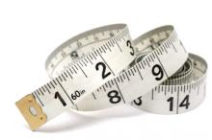**______________________- used to measure ______ inches or more**

**& _______________________ areas.**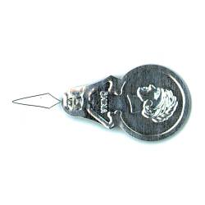

**2.__________ __________________________- can help you thread a _____________________.**

1. 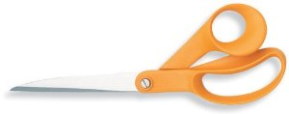 **______________________________- used to cut ______________only! Orange handles are for people who use right hand, orange-red for left handed people.**

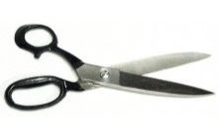

1. **_____________________________- these have a _______________ colored**

**handle and are good to cut ________________ & ________________.**

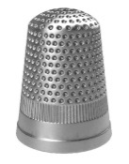

1. **_____________________- used to protect your fingers while sewing by__________________.**

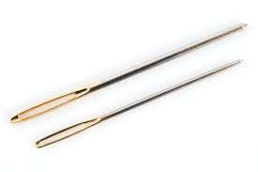



**____ ___________________________-use to pull thread through fabric. The**

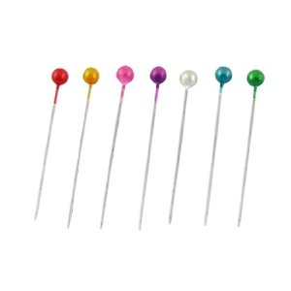 **opening where you put the thread is called the ___________.**

1. **______ _____________________- used to hold two pieces of fabric together.**

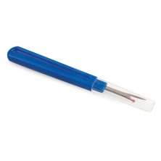

1. **________________________________- helps remove _____________ stitches.**

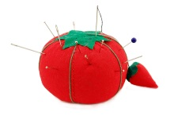

1. **_______________________________- holds ___________________pin.**
2. 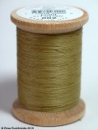 **_______________________________-a long, thin strand of cotton and/or nylon and is attached to a_______________. Used hold**

**two pieces of fabric together**.